Laboratorul 6

*Dispozitive electronice și electronică analogică*

Tudor Diana Ioana

Constantinescu Vlad

Ghindea Daniel

Cozma Andrei

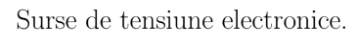

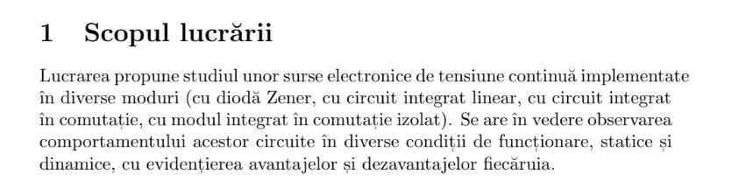 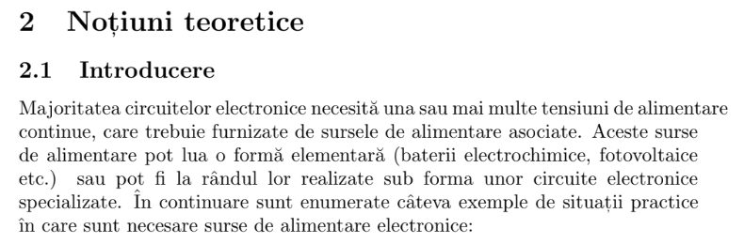

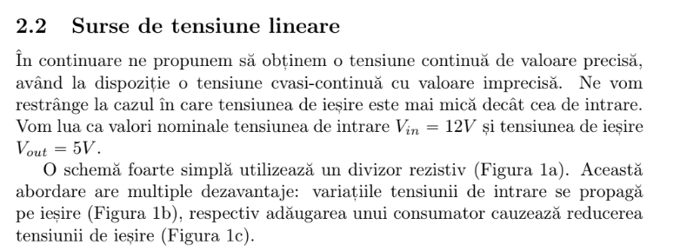

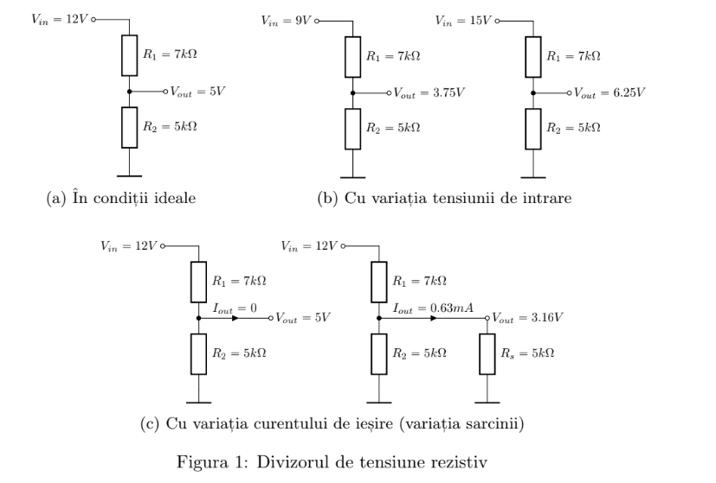

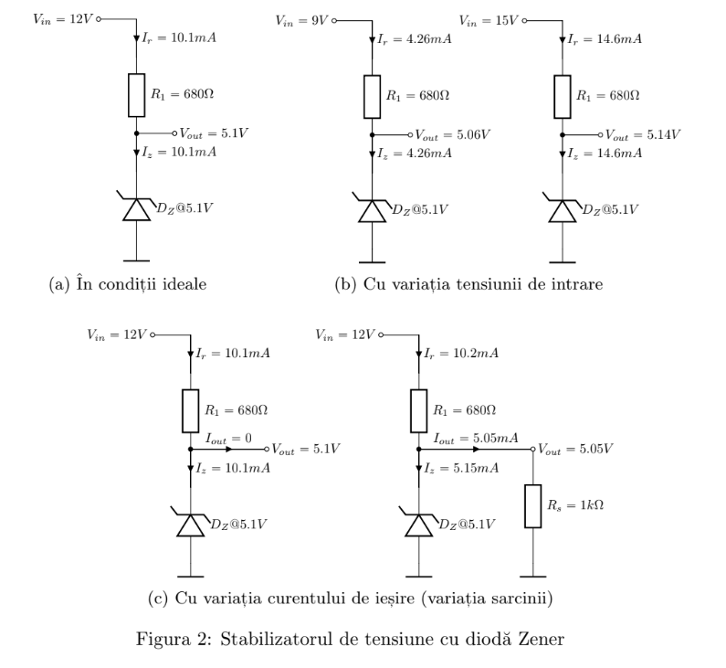

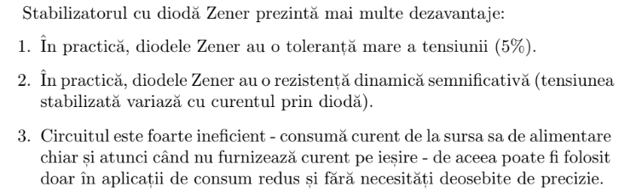

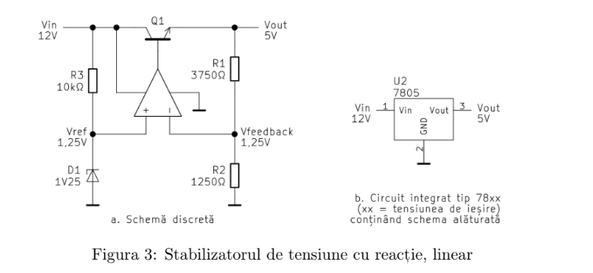

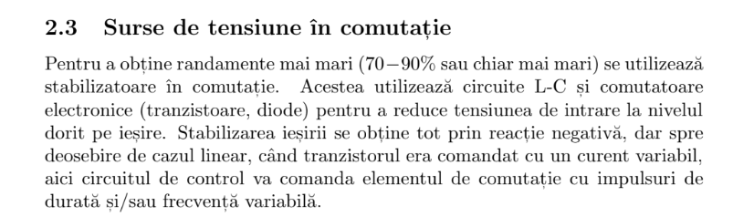

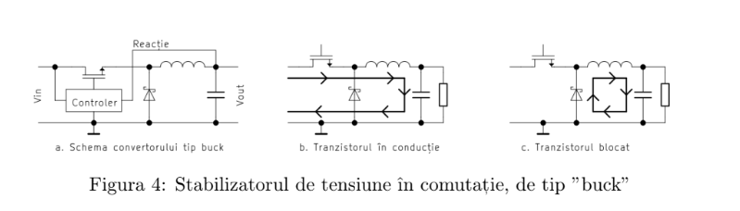

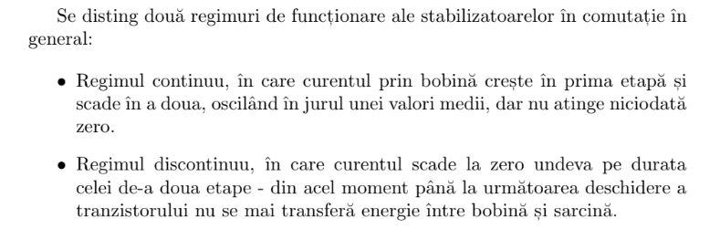

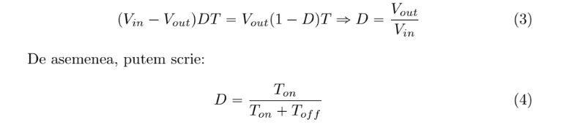

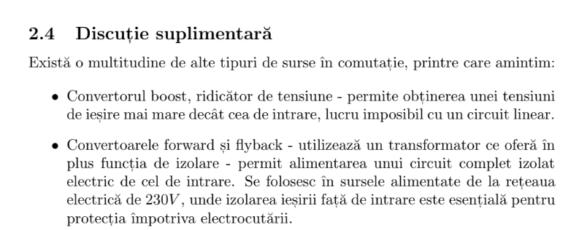

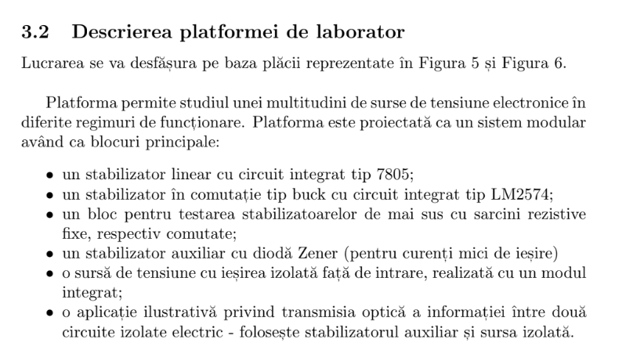

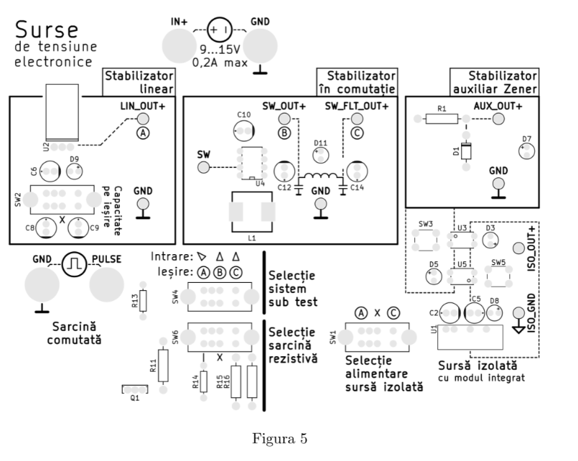

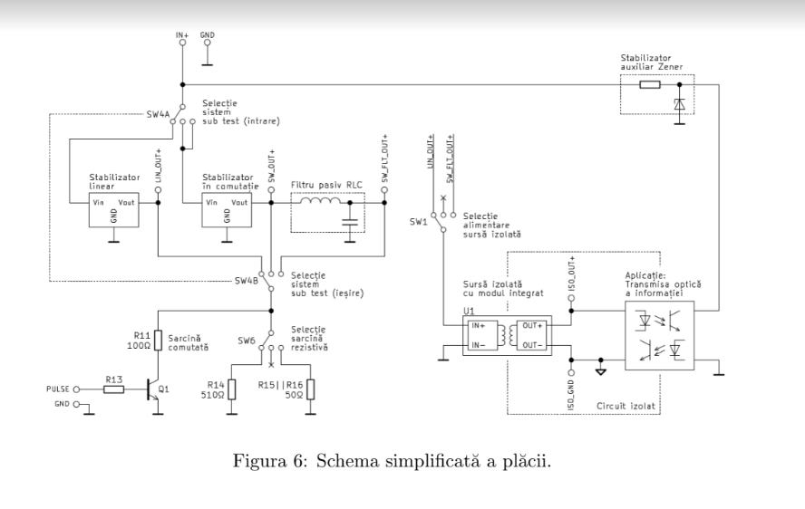

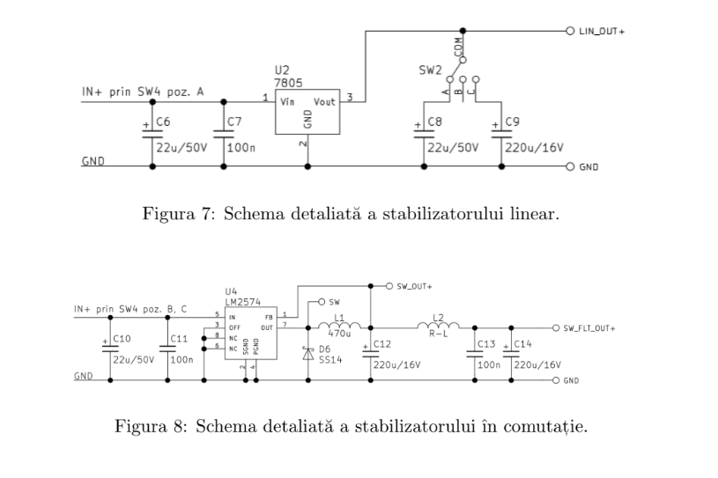

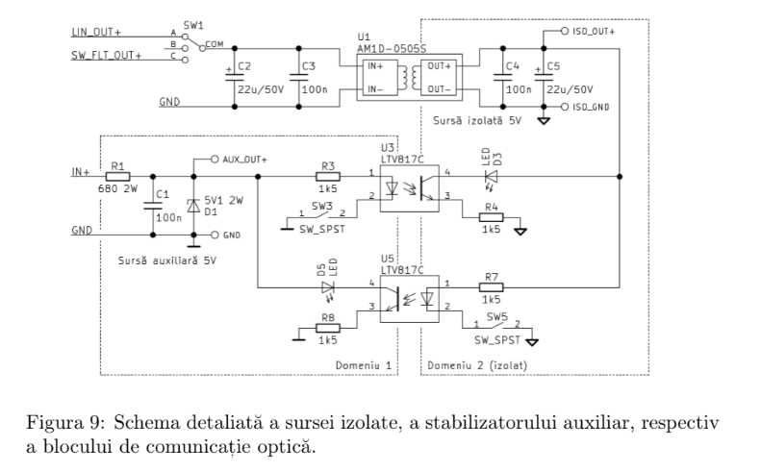

|  |  |  |  |  |  |  |
| --- | --- | --- | --- | --- | --- | --- |
| **Tensiunea de alimentare(Vin)** | **15** | **12** | **9** | **8** | **7** | **6** |
| **Cu iesirea in gol(Vout)** | **5.61** | **5.61** | **5.59** | **5.59** | **5.49** | **4.82** |
| **Cu SW3 apasat(Vout)** | **5.61** | **5.60** | **5.58** | **5.31** | **4.70** | **4.11** |

|  |  |  |  |  |  |  |
| --- | --- | --- | --- | --- | --- | --- |
| **Tensiunea de alimentare(Vin)** | **15** | **12** | **9** | **8** | **7** | **6** |
| **Cu iesirea in gol(Vout)** | **5.05** | **5.06** | **5.05** | **5.05** | **5.05** | **4.47** |
| **Cu sarcina 500Ω(Vout)** | **5.05** | **5.05** | **5.05** | **4.86** | **4.18** | **3.68** |
| **Cu sarcina 50Ω(Vout)** | **Defect** | | | | | |

